**Modeling Breast Cancer in Patients**

By Raehash Shah

**Project Proposal:**

1. **Project Description**

My term project, Breast Cancer Visualizer, is a tool used for researchers to visualize different types of mutations for cells. The tool will be visualizing cancer cells at the cell level, DNA level and the organelle level. The cells will then be visualized after mutation. Once again, this will be visualized at the multiple levels. In addition to visualization the user will interact with the cells to see them at a 3D perspective the breast cancer.

1. **Competitive Analysis**

There are few cancer visualizers that are currently published. Each of these are more visualizations of the data published by cancer cells and the genes that are described by the cancer cells. One example is a Cervical Cancer Tool which demonstrates the publicly available dataset which describes the demographic regions with maps and the cases that are found with the Cervical Cancer across multiple regions. Another concept is the organ pixilation graph image which have been used (1,2)

Another couple of tools that have been used are using multidimensional cancer genomics data where there is a heatmap regarding the clinical data and genes. Then there is a concept of using chromosomal coordinates to identify the specific targeted gene that is of focus and the interactions between the genes do exist. There are others also which have real-time visualizations of cancer genomics data and these are all currently existing tools.

However, the unique concept of my visualizer is to simplify the complicated genomics data to at a basic level where the user can visualize the complicated topic of cancer and mutations (different types) at the multiple different levels described in my project. So although there is a similar concept and purpose, the actual application and visualization is quite different between the different applications and my project.

1. <https://www.jhsph.edu/research/centers-and-institutes/health-services-outcomes-research/_images/Materials/Data%20Visualization%20Tools%20Dr.%20Botsis.pdf>
2. <https://deainfo.nci.nih.gov/advisory/bsa/0520/Miller.pdf>
3. <https://genomemedicine.biomedcentral.com/articles/10.1186/gm413>
4. <https://academic.oup.com/nar/article/48/W1/W415/5835823>
5. **Structural Plan**

There are 3 levels as described before, a cell level, DNA level and an organelle level. Each of these different levels can be visualized as a 3D perspective and for 3 different types of Breast Cancer mutations. At the cell level, you will see the interaction between cell to cells, then at the organelle level between the proteins and a visualization of the DNA and finally the DNA level where you can see the nucleotide mutation.

1. **Algorithmic Plan**

The most complicated part of the Breast Cancer Visualizer besides adding a 3D complex visualization for each of the 3 levels, is incorporating the mutation concept into the different levels. Specifically, how to make it clear that there is a mutation that occurred and to make that vivid description. This algorithmic process not only needs to be easy to manipulate and work with but also involve complicated features. One way of approaching this is by creating an easy data structure which can be manipulated but also not immutable so there has to be many different ways of approaching this. Another thing, that will be quite a complex algorithmic plan is to mimic the idea of floating in a cell space. This has to be the way of visualizing the 3D concept where there needs to be math and color wheels to make each of the aspects more complicated. Another thing is to mimic the idea of moving when the user pans to see the cells also moving at the same time.

1. **Timeline Plan**

All visualizations at the 3 perspectives by November 30th.

The Preliminary Algorithmic plan with basic mutations of the cells by December 2nd.

Start to a 3D visualization of all of the cells/DNA/organelles described by December 5th.

Incorporating a complex algorithmic process while incorporating a more interactive experience for the user by December 7th.

Add additional modules like web-scraping by December 9th.

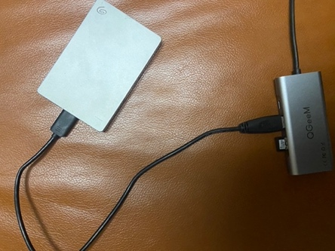

1. **Version Control Plan**

For Version Control, I have used an external hardrive (image below) to back up my code and files. Each of my files for the programs and code are kept in separate files and separate folders for each date that I’ve worked on the project. This allows for me to reference different dates in time where there were successful prototypes and a previous version.

1. **Module List**

Until MVP, I am not planning on using any external modules. After MVP, I may consider working with some modules for web-scraping to extract data or other modules to add for visualizations.